

**PARALLEL AND DISTRIBUTED SYSTEMS**

**PROJECT DOCUMENTATION**

#### TABLE OF CONTENTS

CASE STUDY

REQUIREMENTS ANALYSIS

TOOLS

USER ROLES

SYSTEM ARCHITECTURE

DATABASE

BUSINESS COMPONENT

.NET REMOTING

WEB SERVICE AND CLIENT WEBSITE

DEVELOPING A JAVA CLIENT

#### GROUP MEMBERS

1. Kevin Muiga – SCT212-0065/2019
2. Cynthia Kamau – SCT212-0064/2019
3. Victor Mwaniki – SCT212-0066/2019
4. Newton Kamau - SCT212-0079/2019
5. Mercy Syonzi – SCT212-0580/2018

#### CASE STUDY

* Out Of Bounds Ltd is a London-based company which specialises in the management of software development projects
* Out Of Bounds Ltd has several teams of project managers and developers who are experts in a various fields of technology
* Some of Out Of Bounds Ltd’s teams are based at their London premises, but others are at geographically distant locations (e.g. Sri Lanka,India, Spain, Slovakia, etc.)
* For certain projects, work is outsourced to other companies.

While the current provisions work, they are not very effective and it is often a difficult task for the

project managers to know what the exact state of the project is

• To aid the project managers and team leaders in the project coordination task, Out Of Bounds Ltd is developing a software system which will facilitate the task

• The software system will be called – Project Tracking System (PTS)

Project Tracking System:

– This system will allow a manager to register projects

– Projects are divide into tasks

– Rules regarding the order of tasks can be set

– Different tasks can be assigned to different teams(working for the company or outsourced to external teams)

– The system will provide functionality for team leaders to register task progress. Project progress can be tracked by the project manager

– The customer who commissioned the project can get summary information about the structure of the project, distribution of work and progress.

#### REQUIREMENTS ANALYSIS

One system – serving a number of geographically dispersed users

Different types of users which require different functionality from the system

Possibly different technologies/platforms used by different users

• Need to provide different interfaces – We have different types of users

• Need for a distributed system – Users are in different locations using the same system

• Need for some kind of data layer – Information needs to be stored about projects,

teams, etc.

#### TOOLS

The following software tools will be used during the implementation of the system:

– Microsoft SQL Server 2005

--Including SQL Server Management Studio

– Microsoft Visual Studio .NET 2005

– NetBeans 5.0

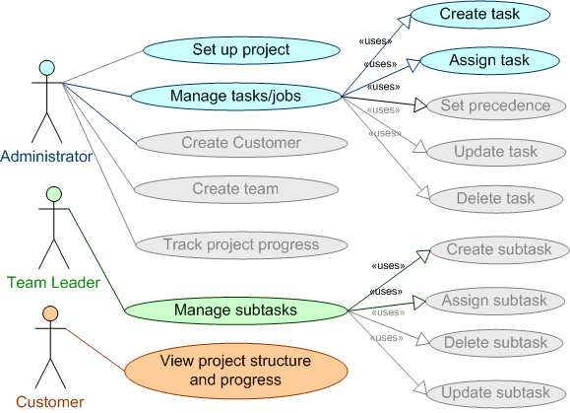

USE CASE DIAGRAM

#### SYSTEM ARCHITECTURE

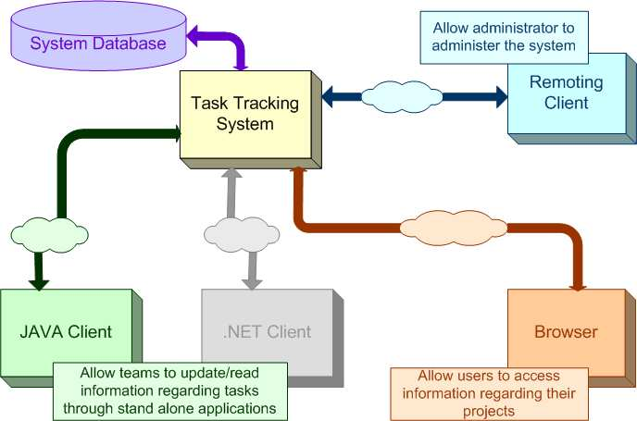

System architecture

#### DATABASE

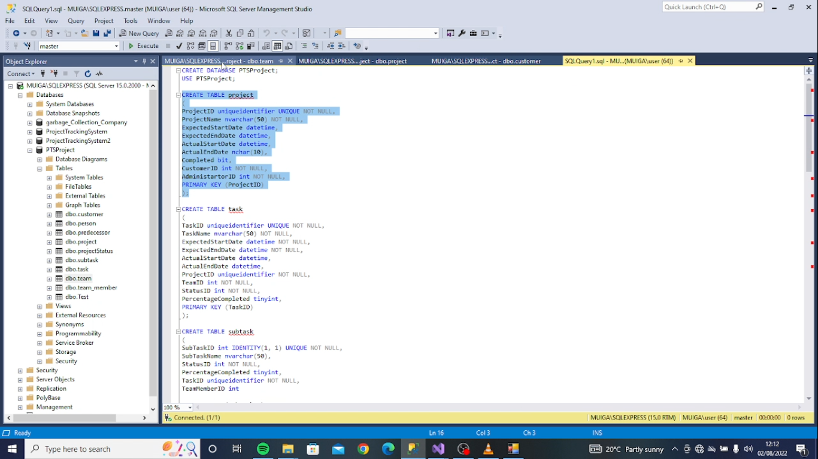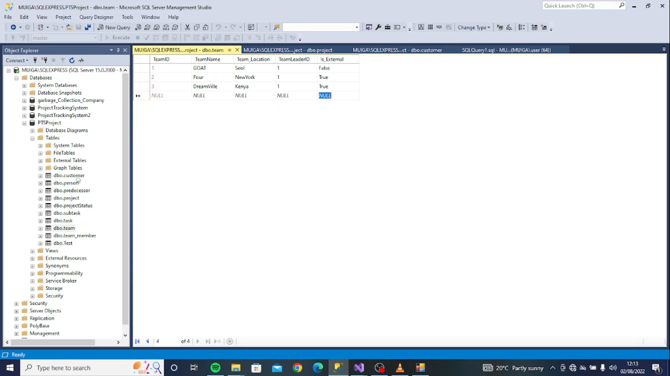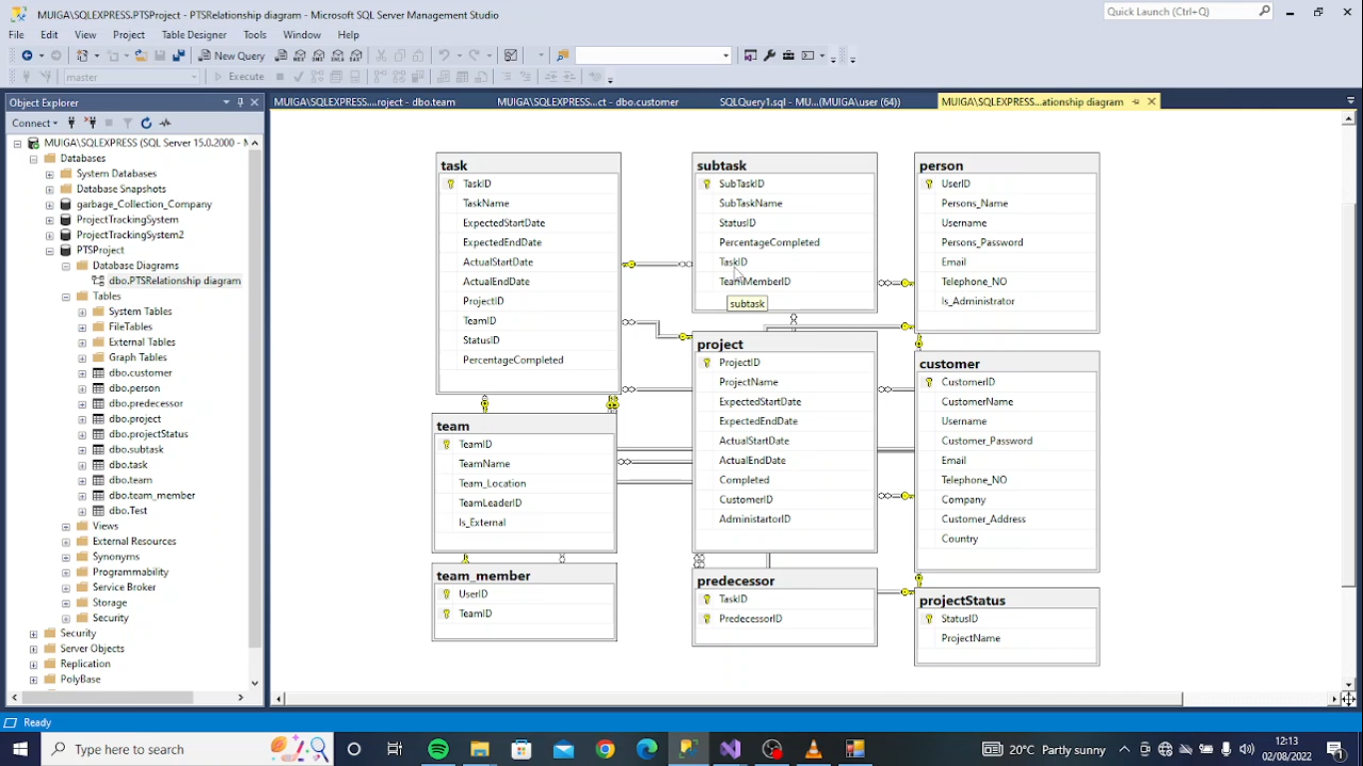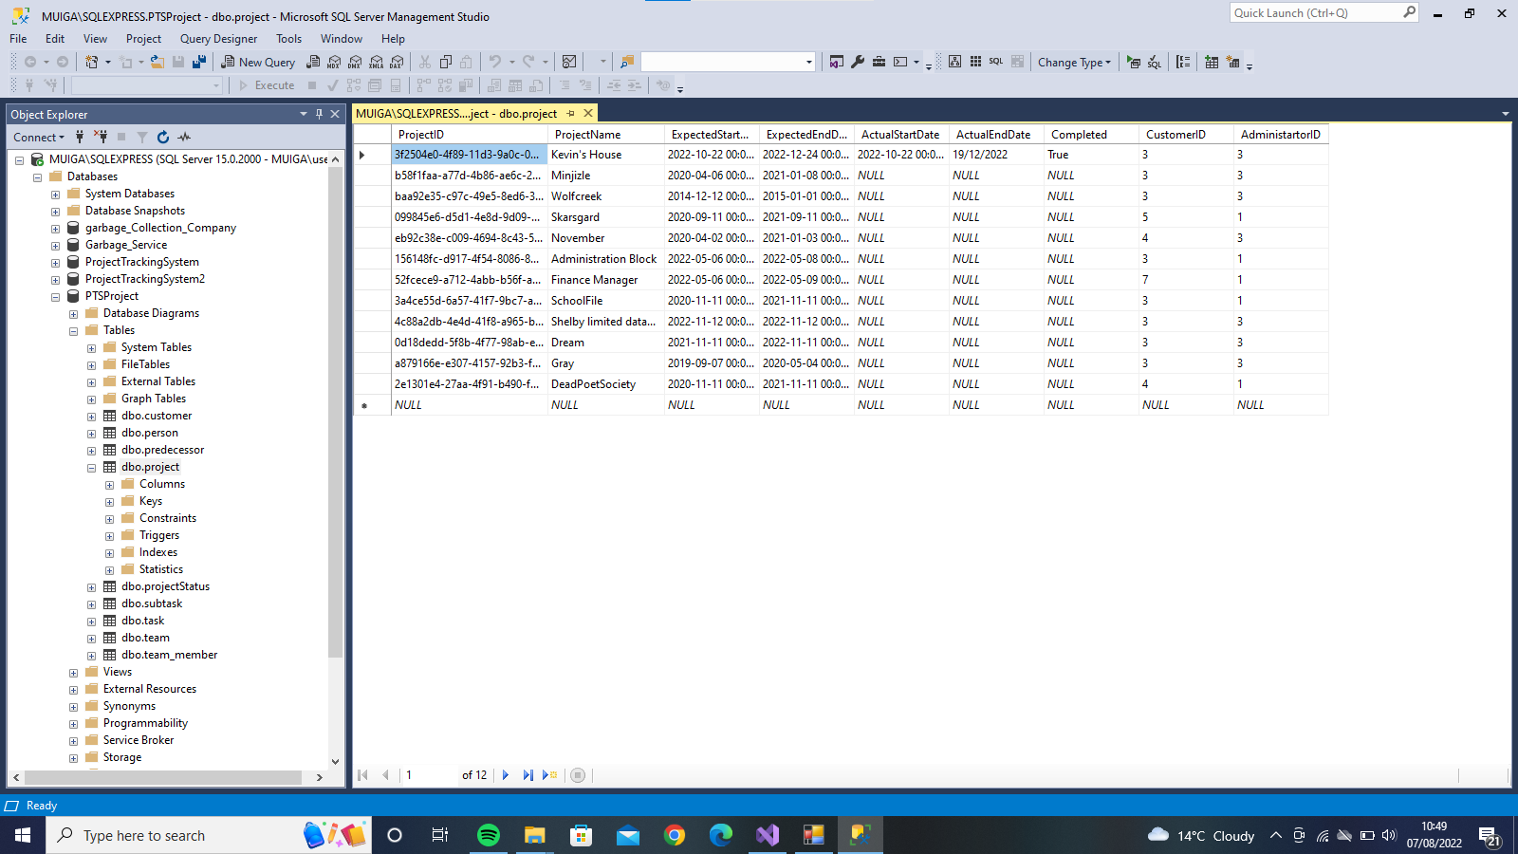

A database has been designed in order support the Project Tracking System.

Entities identified:

* Project: this represents a project
* Task: this represents a task of a particular project. A project may contain many tasks.
* Subtask: this represents a subtask of a particular task. A task may contain many subtasks.

Open the database and enter some data manually such that:

– There is a project entry

– For which there are task entries

– Who point at a team

– Whose TeamLeaderId points at a person entry

• Use the login details for this person in

order to test the Java application

#### BUSINESS COMPONENT

Our component will consist of a collection of classes developed to fulfil a certain specification

• It can be re-used

• It should encapsulate all its behaviour

• It must provide an interface to allow it to be accessed by a client (could even be another component)

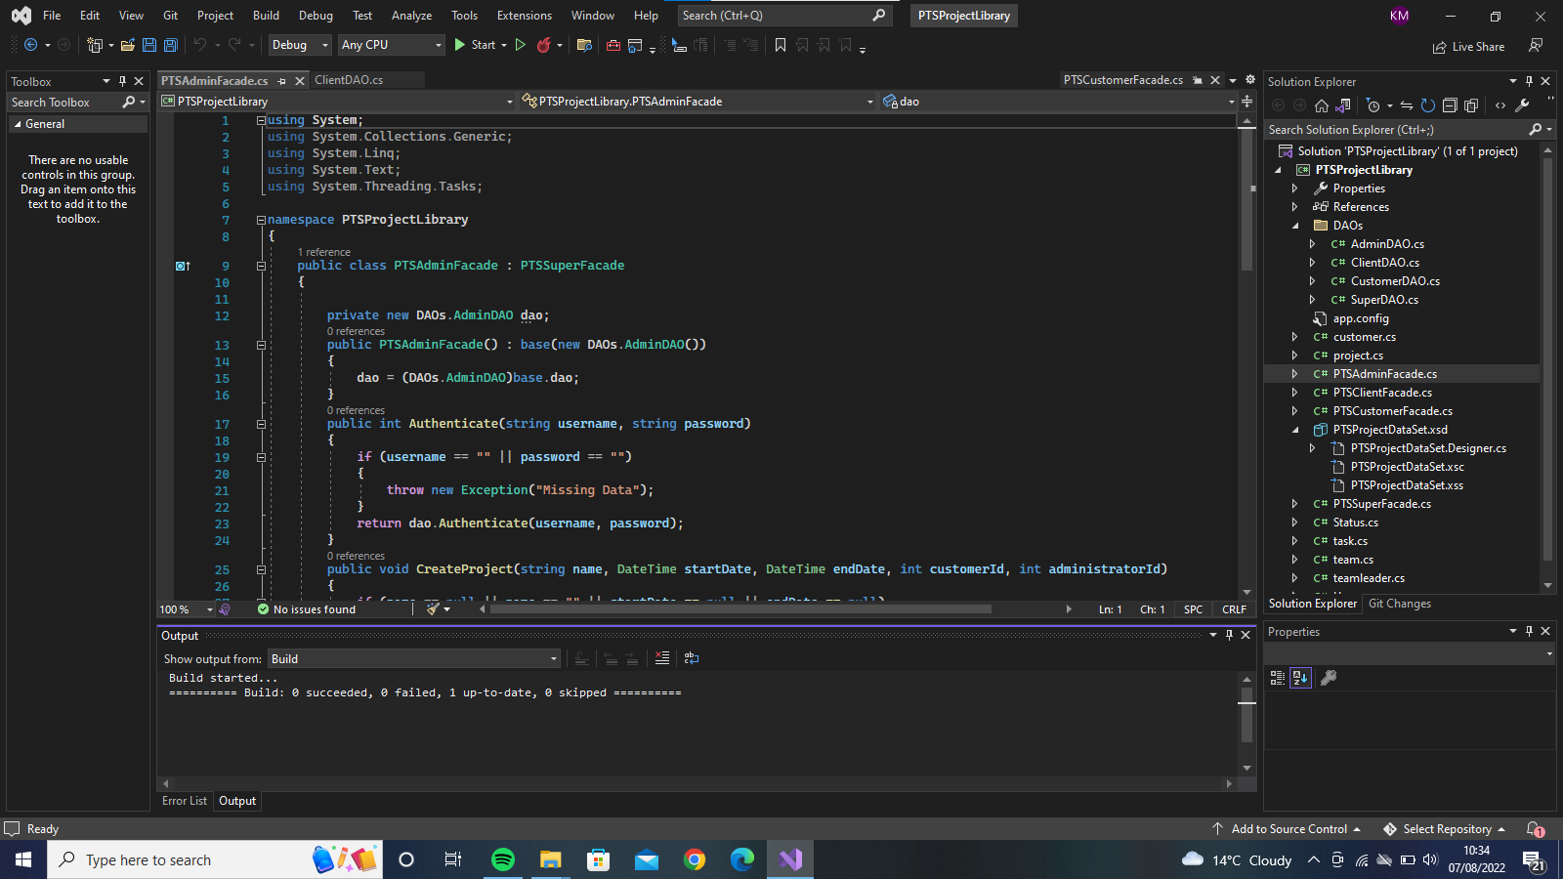

ADMIN USERINTERFACE

* This is to be used by the company administrators to create projects, create tasks, keep track of the projects.
* It was designed using the windows forms and controls that come with Visual Studio

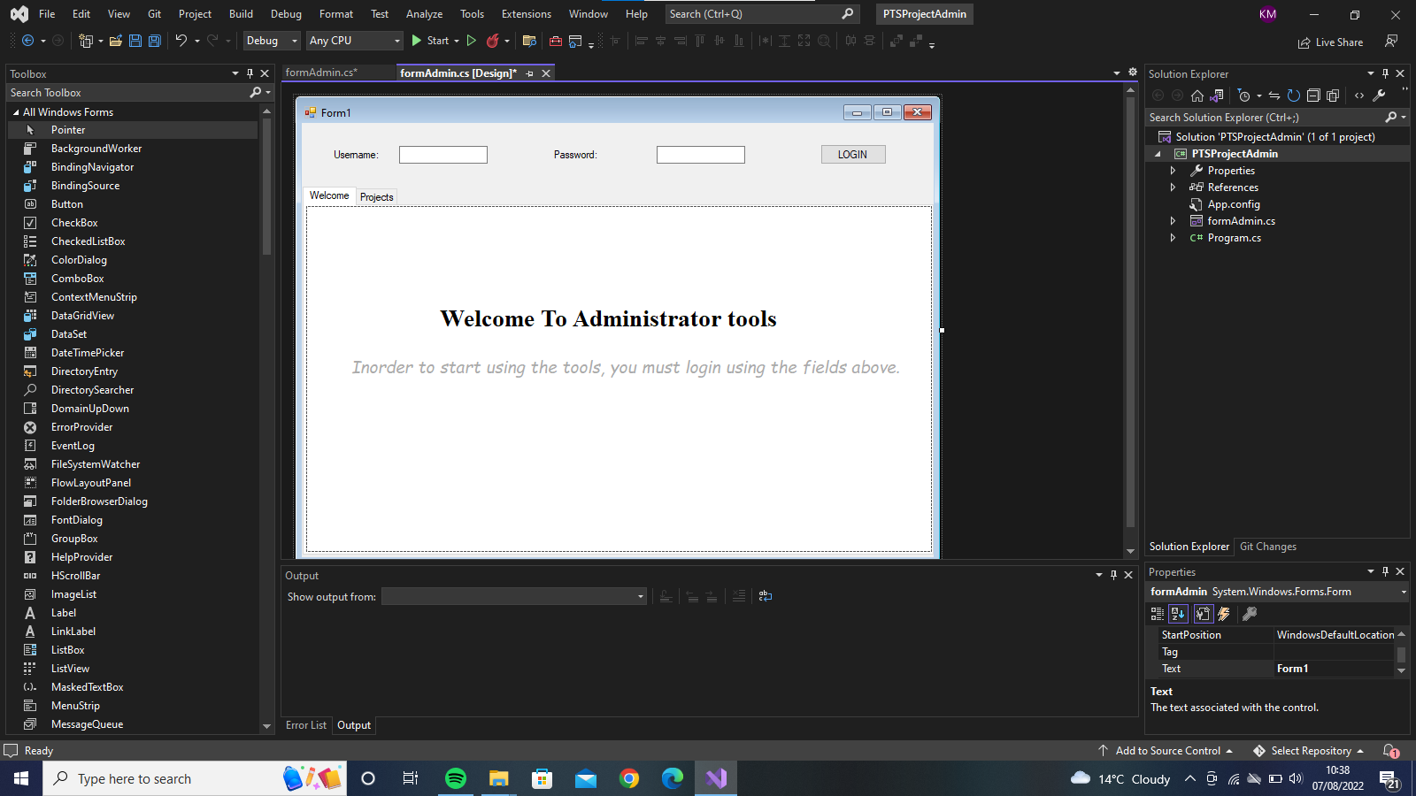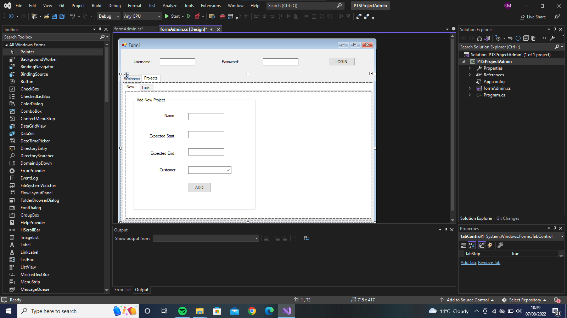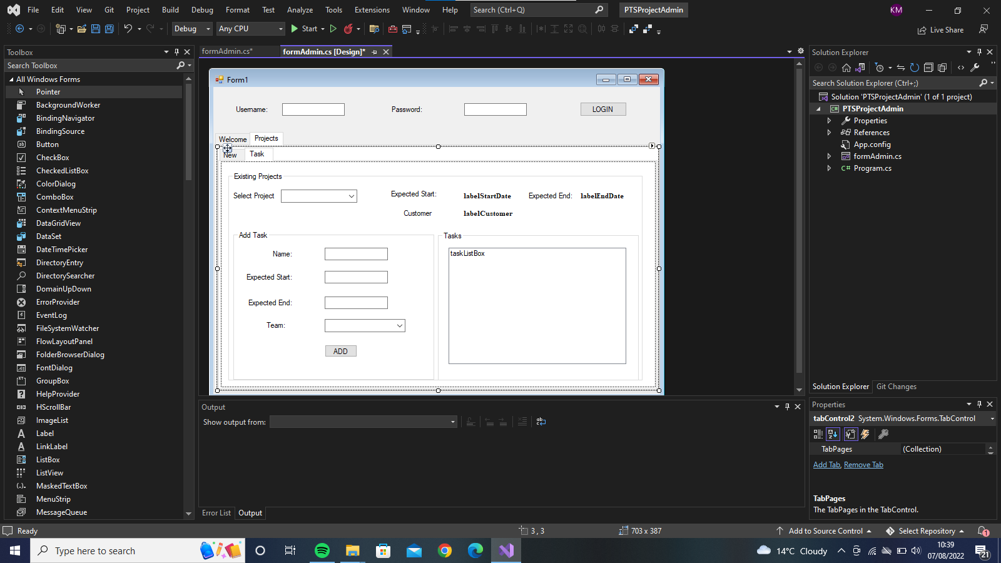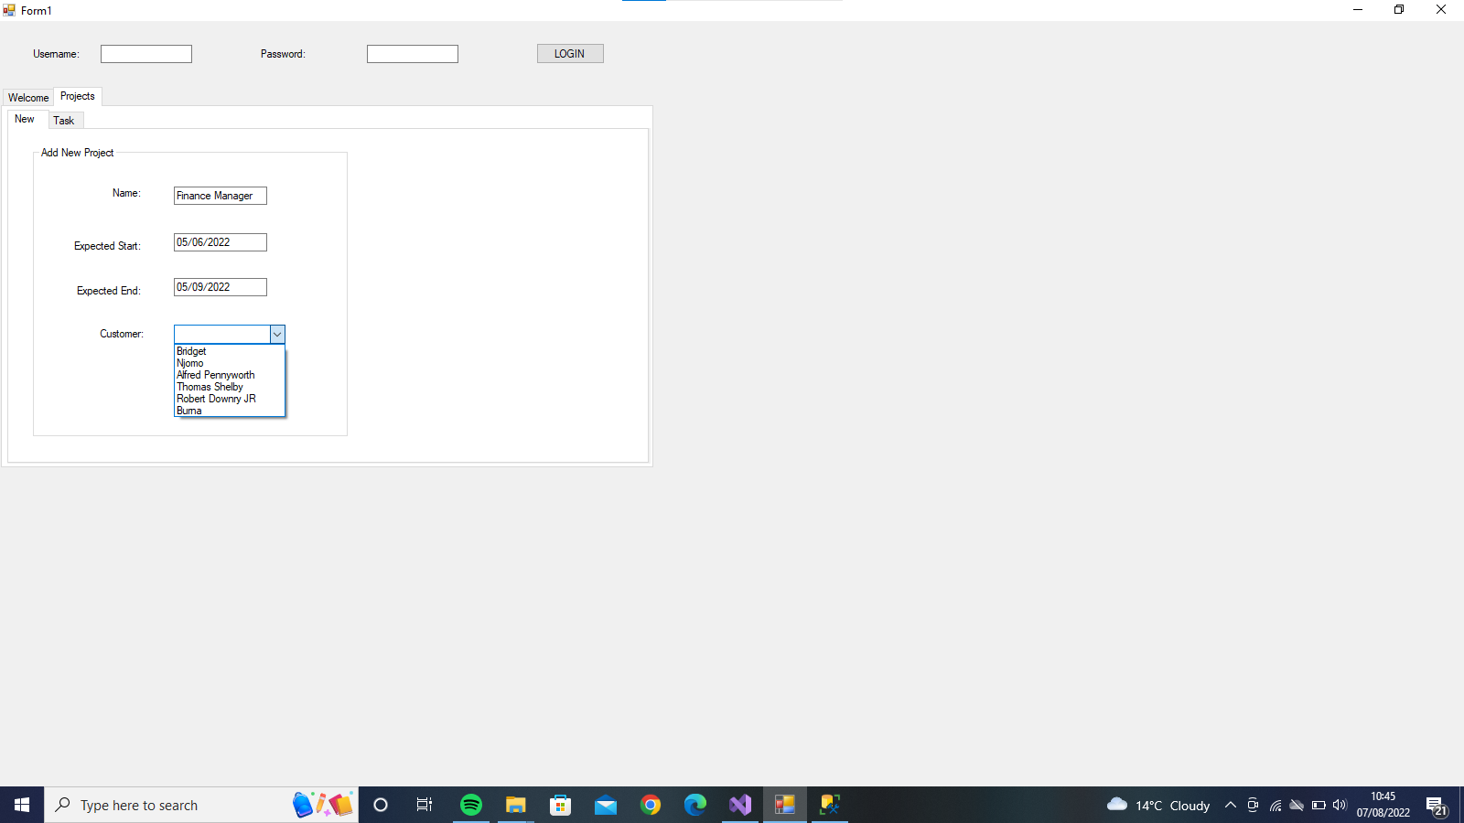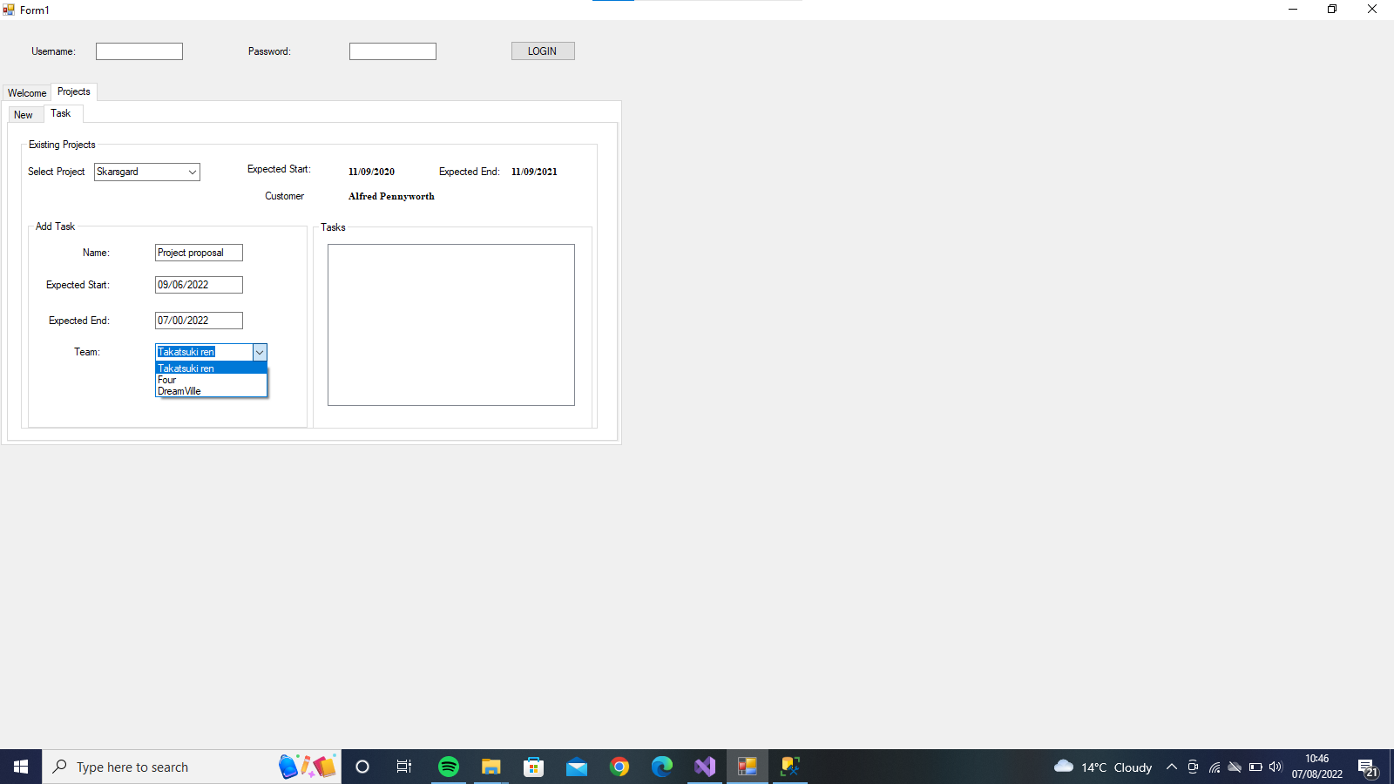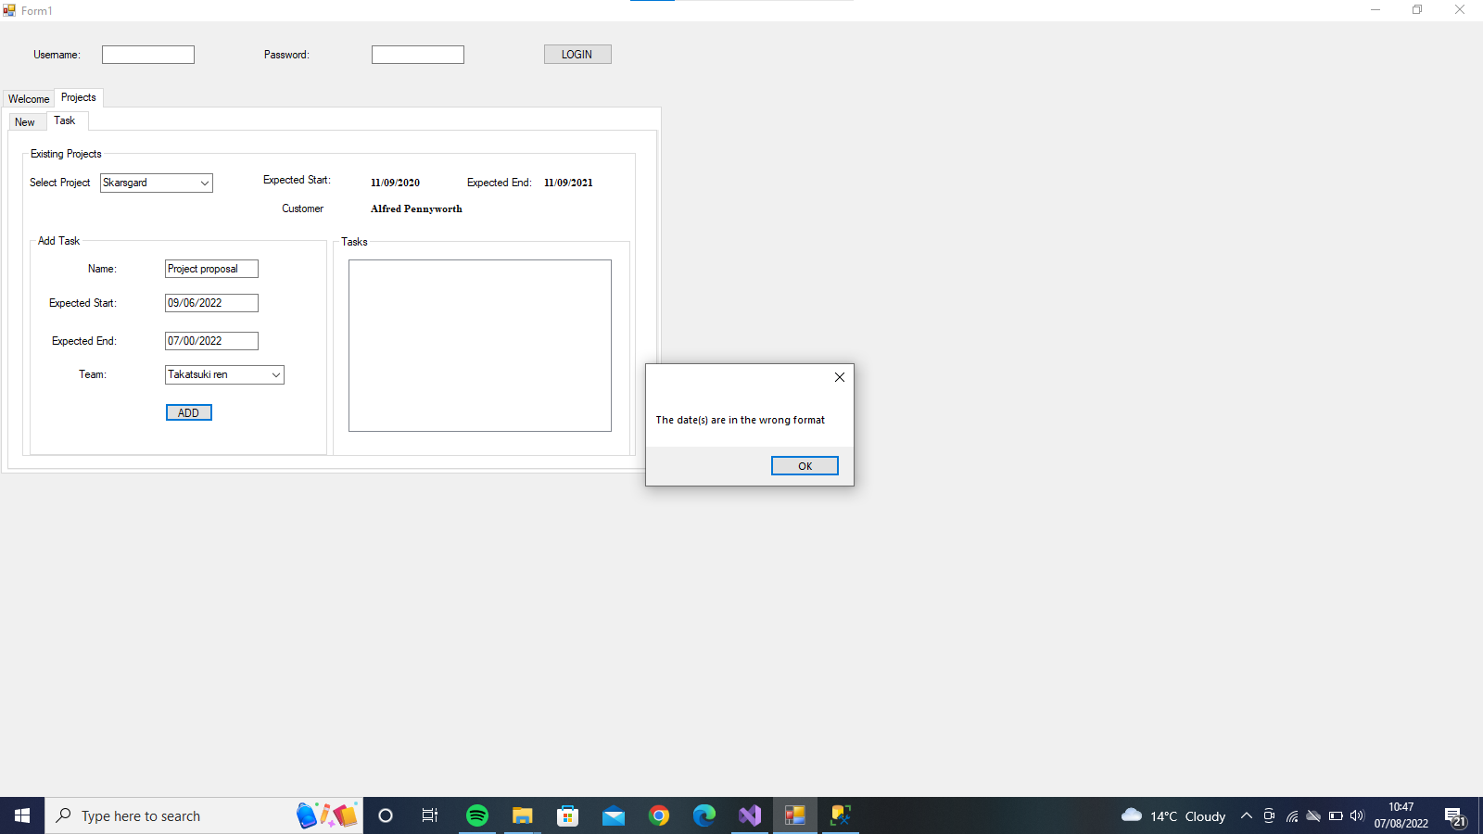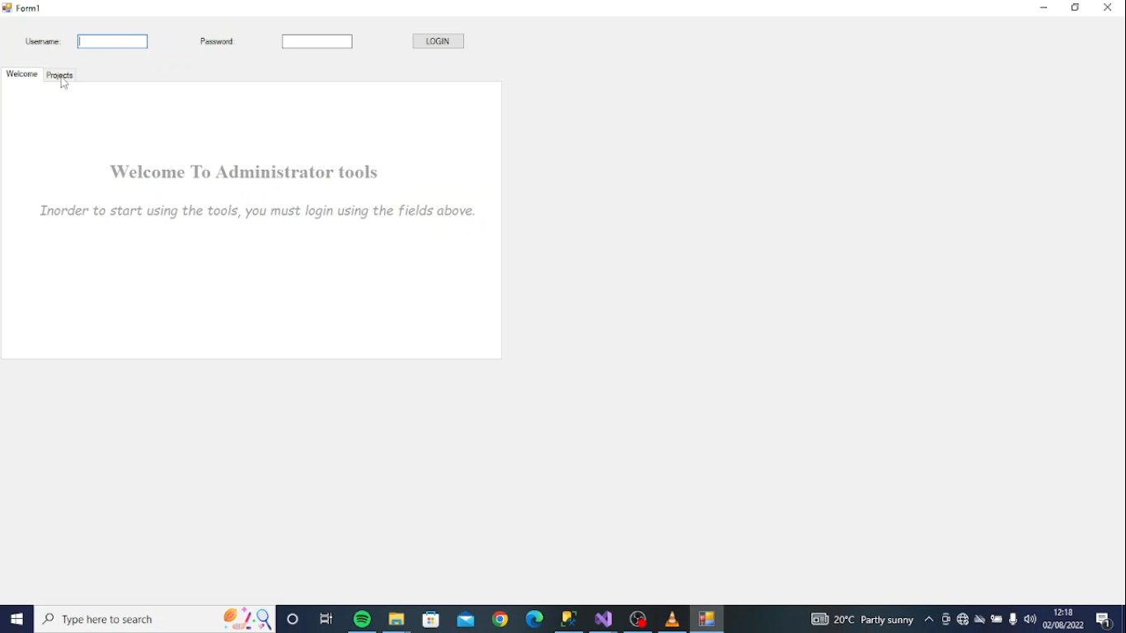

#### .NET REMOTING

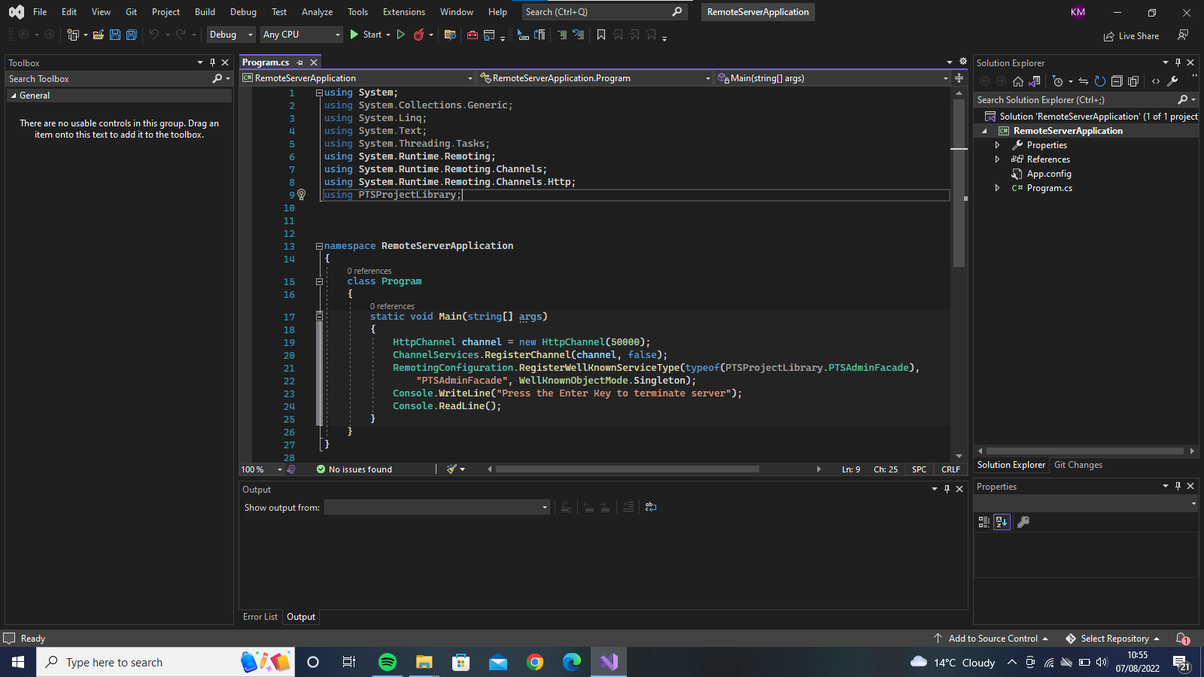

– .NET Remoting: works only when client and server are written in .NET. Can be used when both are under your the control.

We are using .NET Remoting to have the Admin user interface we created communicate with the business component of our project the PTSLibrary.

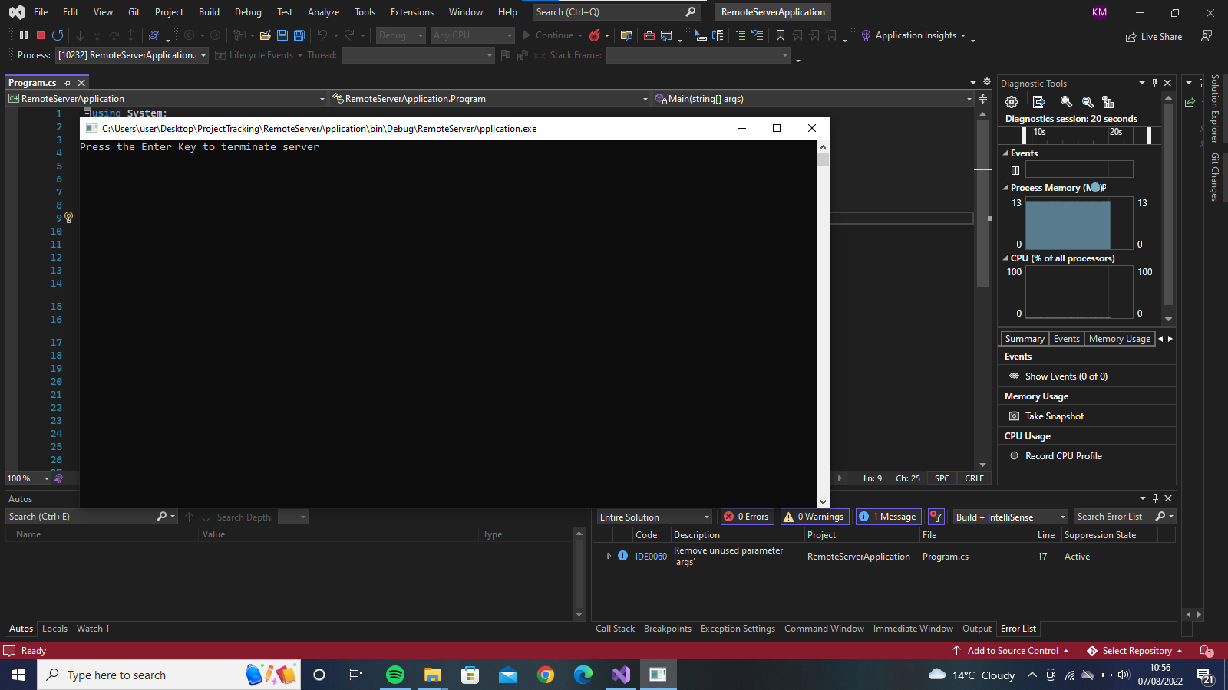

#### WEB SERVICE AND CLIENT WEBSITE

We have two webservices that act as facades for communication with the database. The Customer webservice is the façade for the Customer website and the Customer webservice is the façade for the client side that will be constructed in netbeans.

This is the code for the customer webservices.

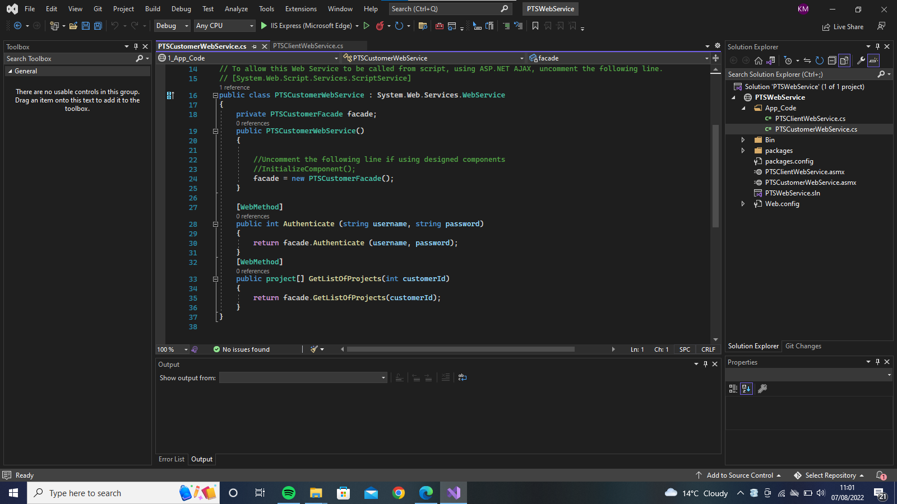

The webservice can be run and opened on a browser where we can test its methods. This is what it looks like in browser.Our two methods are both visible. (The Authenticate method and GetListOfCustomers method)

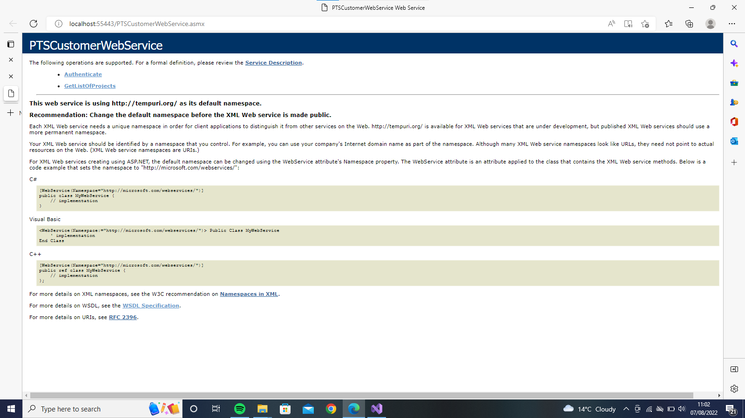

The authenticate method is seen as illustrated below:

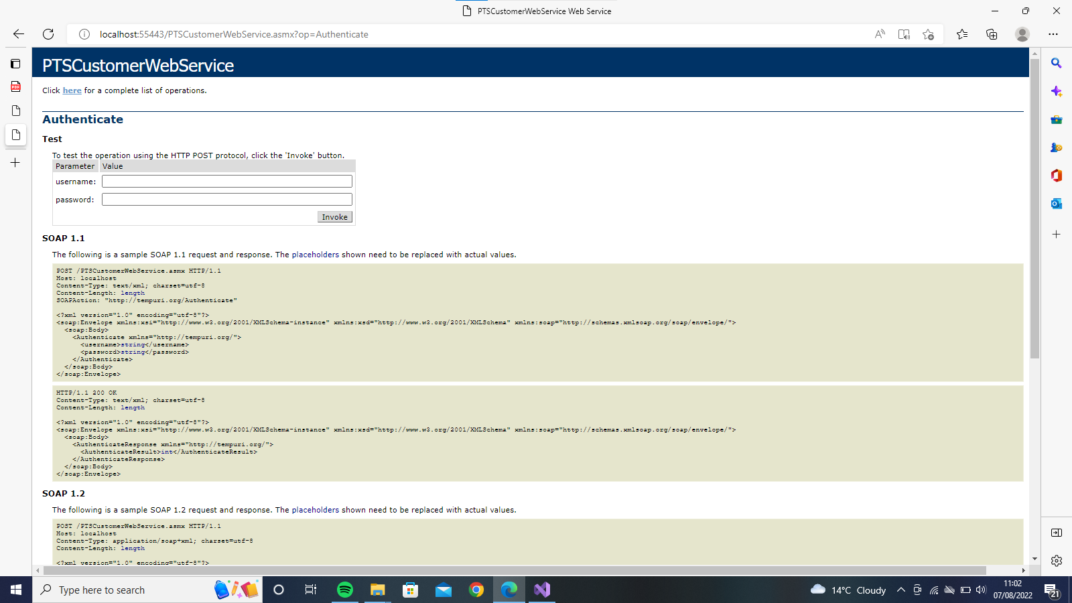

The GetListOfCustomers method :

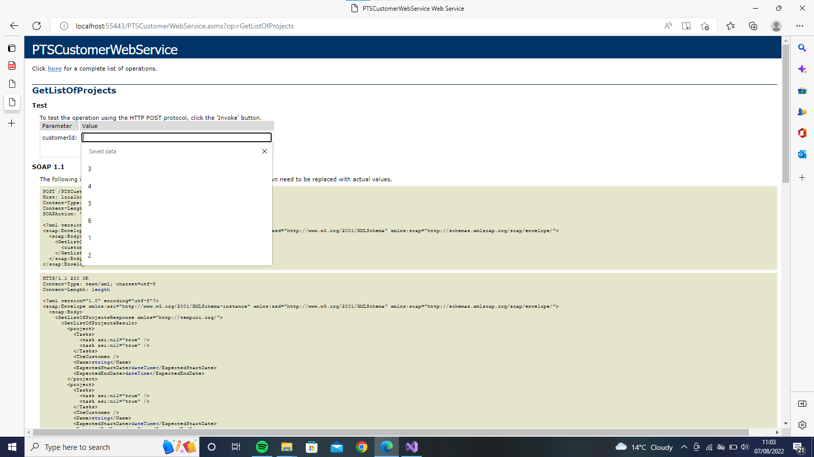

ITS RESULTS:

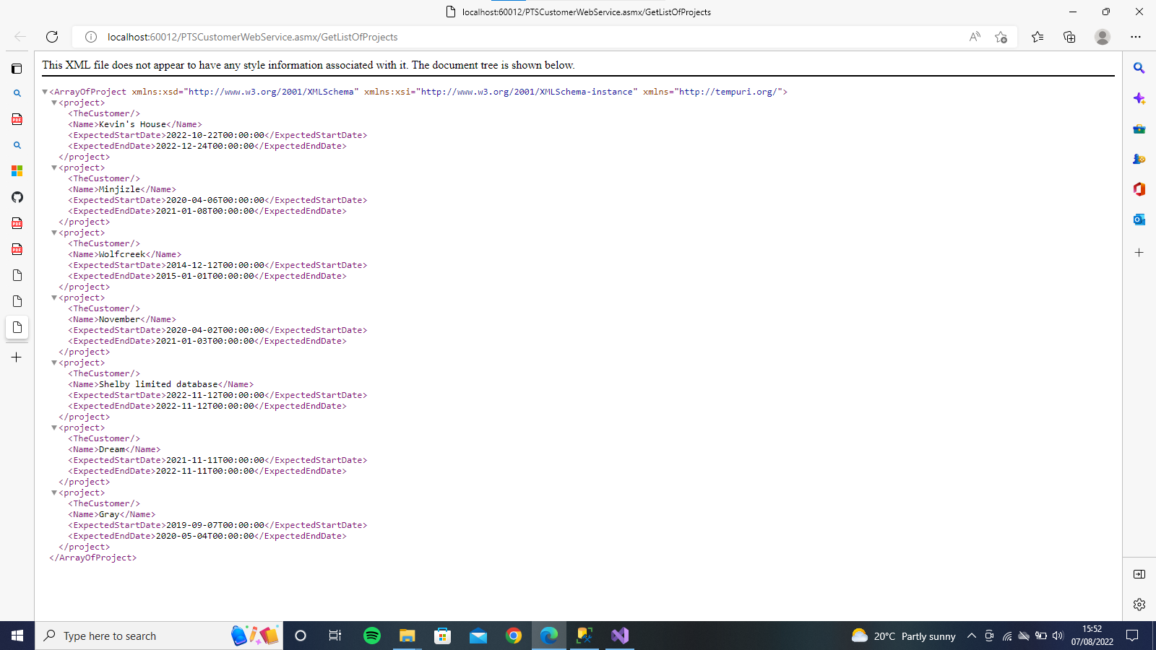

The second webservice is the Client webservice. This is what it would look like displayed on a browser.:

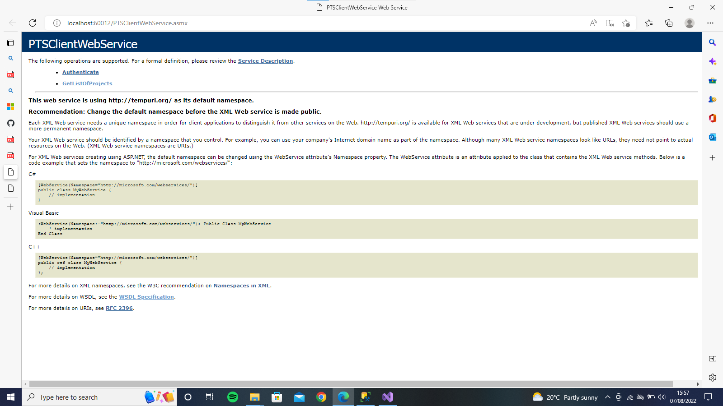

The GetListOfCustomers method:

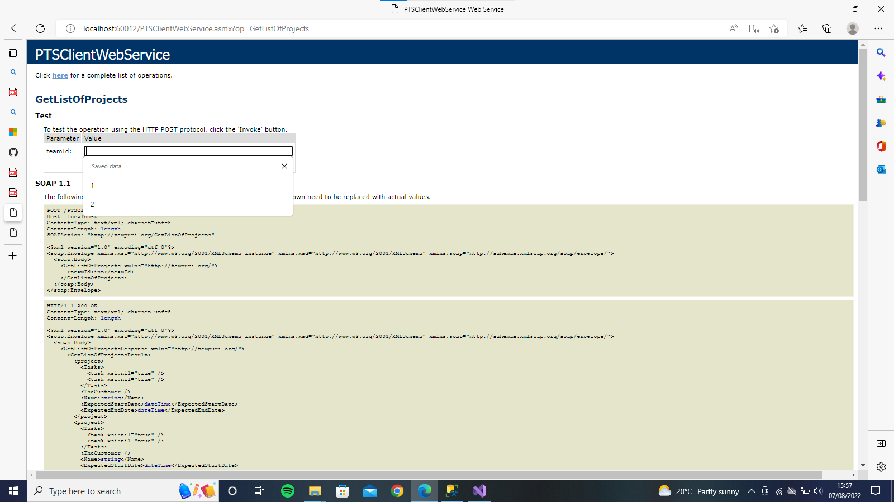

ITS RESLT/OUTPUT:

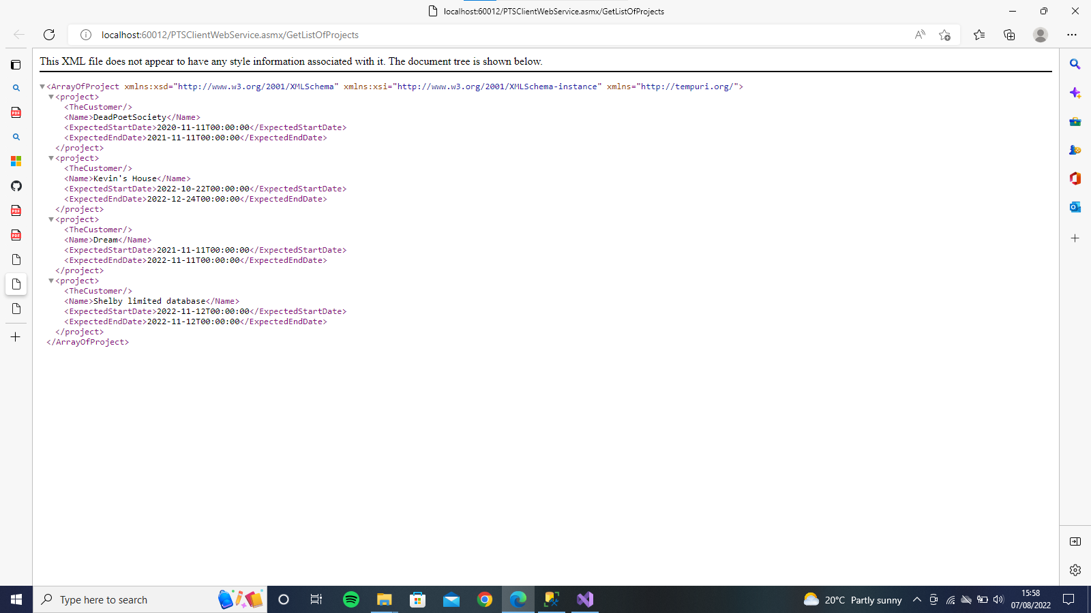

The Customer Website we build to use one of the webservices will look like this: With Textboxes and labels and a login button that allows the verification of customers before they can access the system.

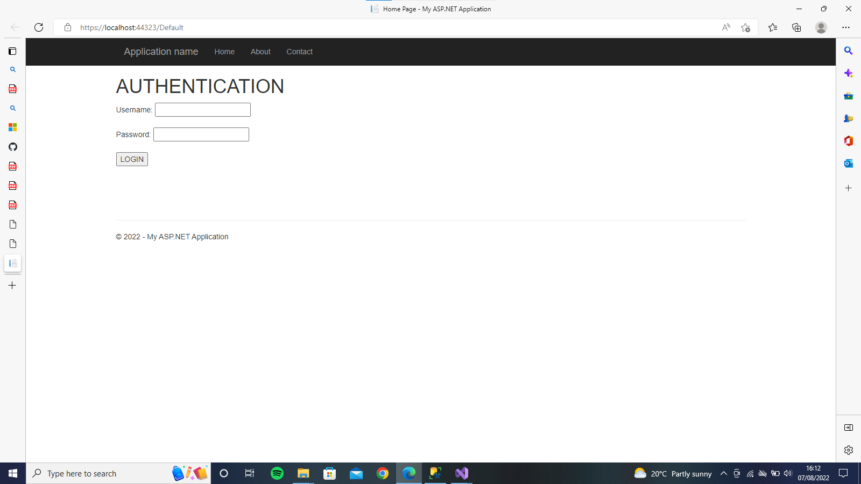

On Login the website checks whether all the login credentials entered are accurate. It displays an error message when the credentials don’t match that of the database and gives a result when they do.

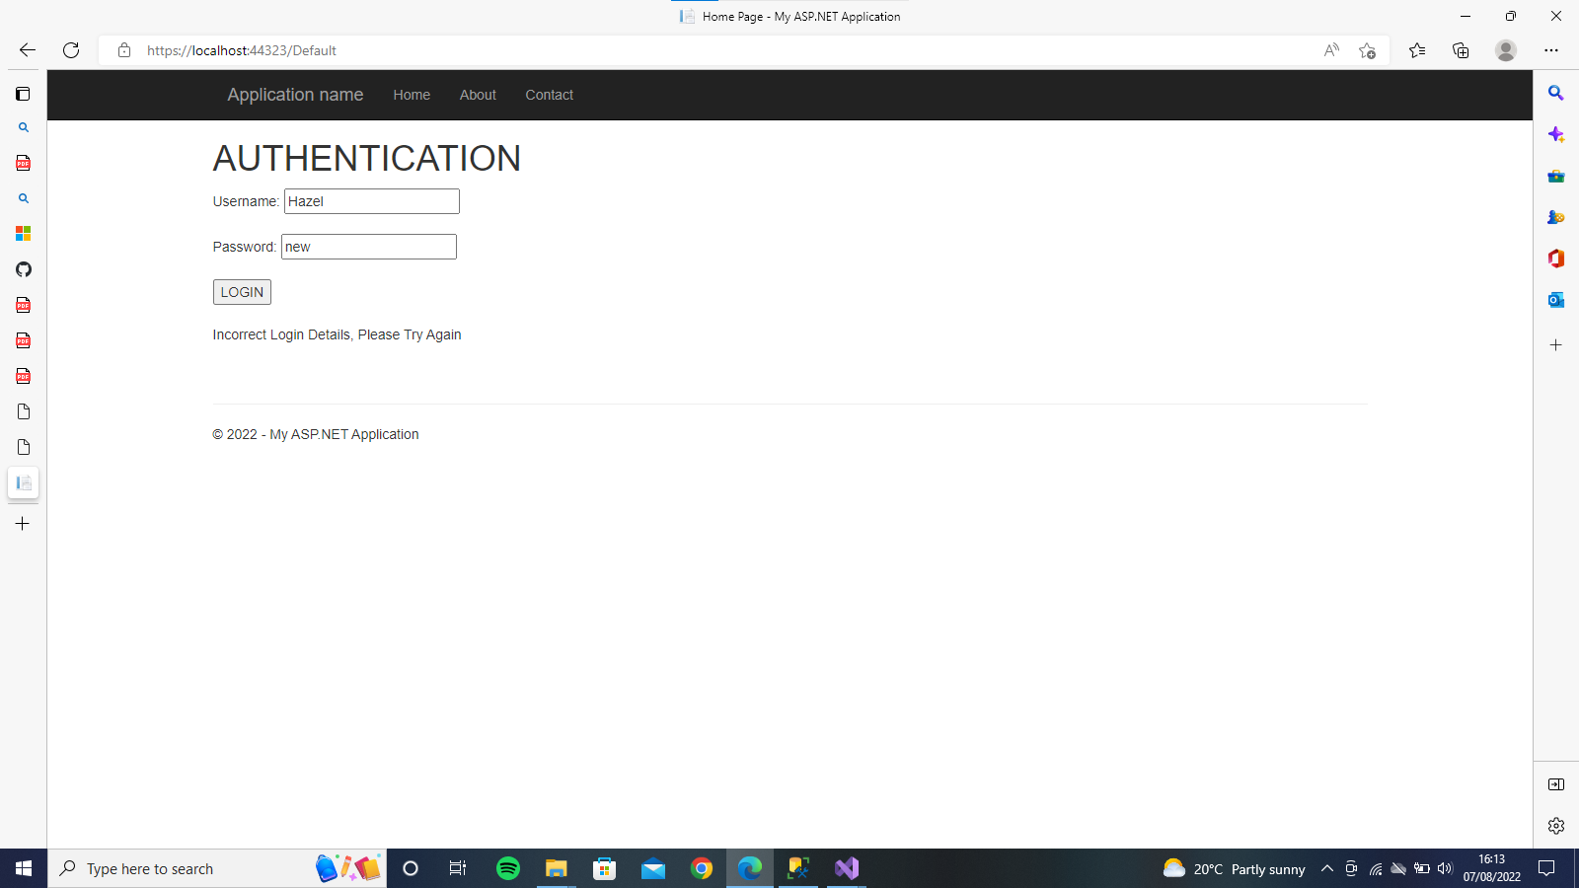

THE RESULTS FROM THE GETLIST OF CUSTOMERS METHOD

If the login details are correct then it runs the GetListOfProjects method and returns the list of projects as shown below.

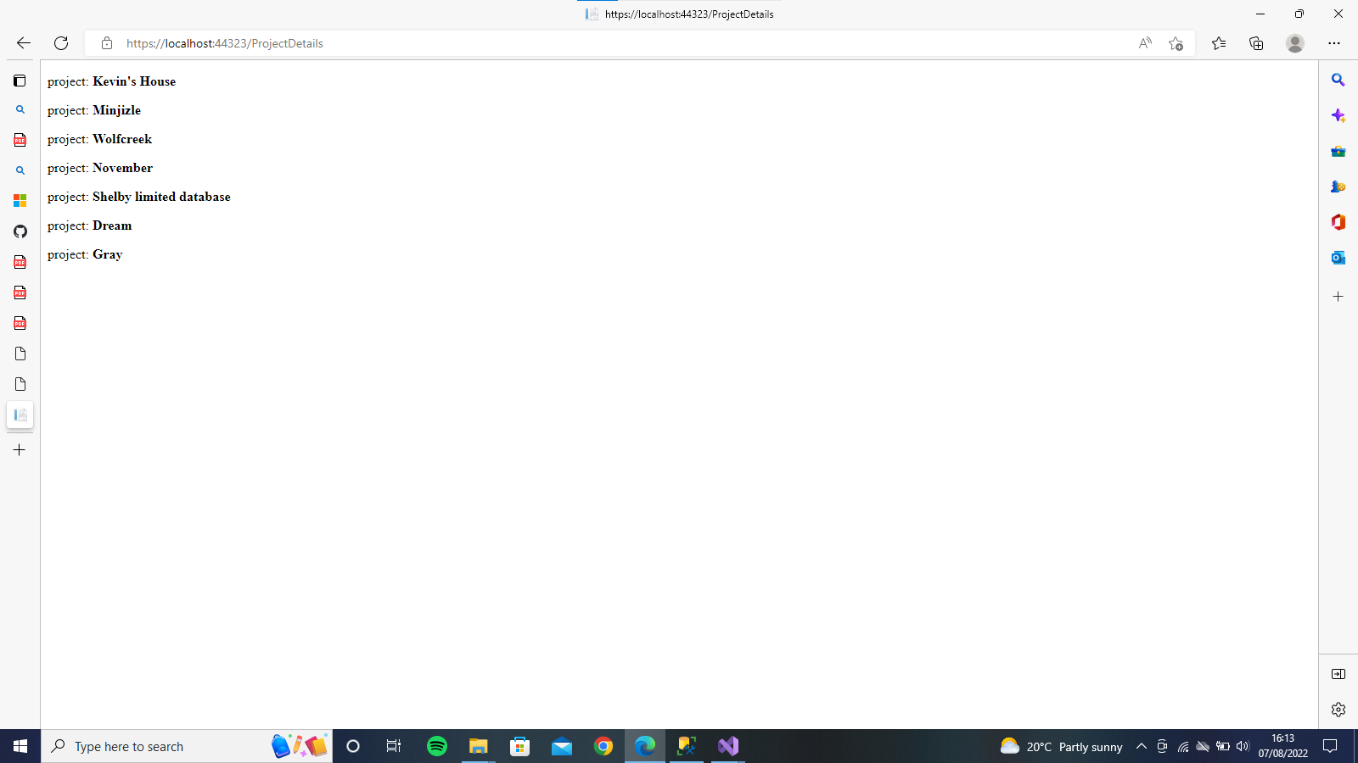

#### DEVELOPING A JAVA CLIENT

Implement a GUI application that enables a team leader to log in and see a list of tasks

that the project manager (administrator) has assigned to them.

The Java application will need to make calls on the .NET web service, so we will need to add a web service client.

• Ensure that the SQL Server database is running and available

• Further, open the PTSLibrary solution, right-click on the PTSClientWebService.asmx file and select View in Browser

– The web service methods should be exposed in the browser

– Copy the URL displayed in the browser

We will design an interface that allows you to login and view the Projects if you are recognized as an authorized individual.

This is the code section of the design view

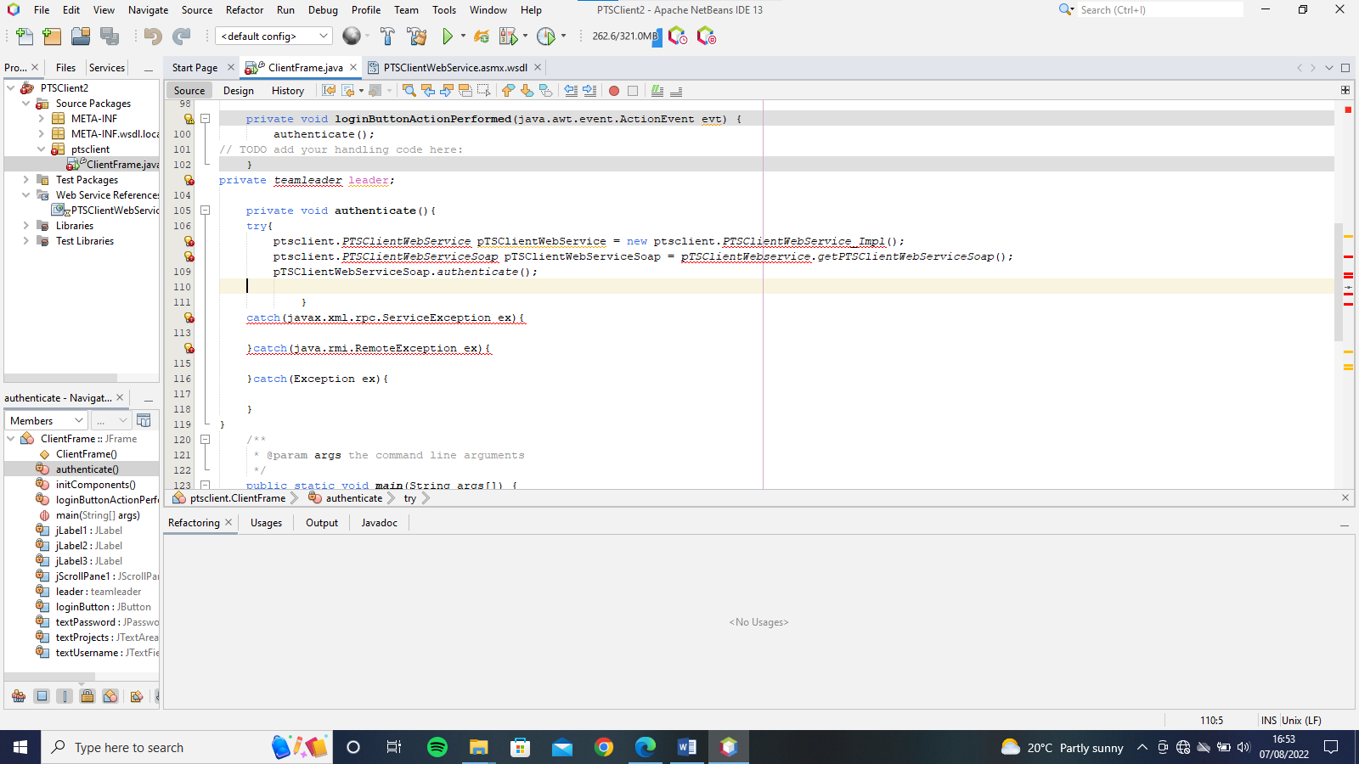

The design for the interface is a simple design. It is displayed in the image below. We have a username label a textField for the label, a password label and a passwordField to input our password in that format. And a text area for displaying the Projects

